Lab – Troubleshooting EtherChannel

1. Topology

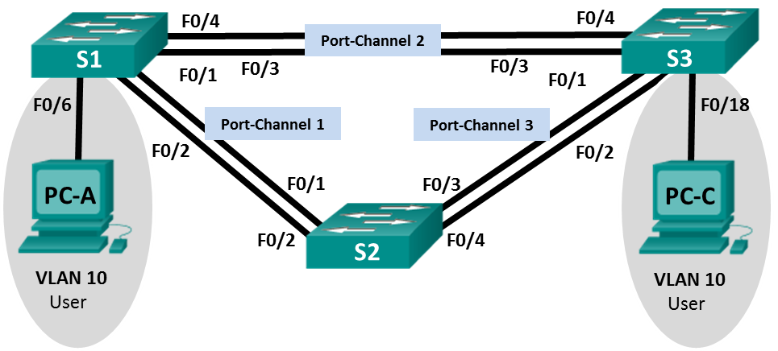

1. Addressing Table

|  |  |  |  |
| --- | --- | --- | --- |
| **Device** | **Interface** | **IP Address** | **Subnet Mask** |
| S1 | VLAN 99 | 192.168.1.11 | 255.255.255.0 |
| S2 | VLAN 99 | 192.168.1.12 | 255.255.255.0 |
| S3 | VLAN 99 | 192.168.1.13 | 255.255.255.0 |
| PC-A | NIC | 192.168.0.2 | 255.255.255.0 |
| PC-C | NIC | 192.168.0.3 | 255.255.255.0 |

1. VLAN Assignments

|  |  |
| --- | --- |
| VLAN | Name |
| 10 | User |
| 99 | Management |

Objectives

Part 1: Build the Network and Load Device Configurations

Part 2: Troubleshoot EtherChannel

1. Background / Scenario

The switches at your company were configured by an inexperienced network administrator. Several errors in the configuration have resulted in speed and connectivity issues. Your manager has asked you to troubleshoot and correct the configuration errors and document your work. Using your knowledge of EtherChannel and standard testing methods, find and correct the errors. Ensure that all of the EtherChannels use Port Aggregation Protocol (PAgP), and that all hosts are reachable.

**Note**: The switches used are Cisco Catalyst 2960s with Cisco IOS Release 15.0(2) (lanbasek9 image). Other switches and Cisco IOS versions can be used. Depending on the model and Cisco IOS version, the commands available and output produced might vary from what is shown in the labs.

**Note**: Make sure that the switches have been erased and have no startup configurations. If you are unsure, contact your instructor.

1. Required Resources

* 3 Switches (Cisco 2960 with Cisco IOS Release 15.0(2) lanbasek9 image or comparable)
* 2 PCs (Windows 7, Vista, or XP with a terminal emulation program, such as Tera Term)
* Console cables to configure the Cisco IOS devices via the console ports
* Ethernet cables as shown in the topology

1. Build the Network and Load Device Configurations

In Part 1, you will set up the network topology, configure basic settings on the PC hosts, and load configurations on the switches.

* 1. Cable the network as shown in the topology.
  2. Configure the PC hosts.
  3. Erase the startup and VLAN configurations and reload the switches.
  4. Load switch configurations.

Load the following configurations into the appropriate switch. All switches have the same passwords. The privileged EXEC password is **class**. The password for console and vty access is **cisco**. As all switches are Cisco devices, the network administrator decided to use Cisco’s PAgP on all port channels configured with EtherChannel. Switch S2 is the root bridge for all VLANs in the topology.

Switch S1 Configuration:

hostname S1

interface range f0/1-24, g0/1-2

shutdown

exit

enable secret class

no ip domain lookup

line vty 0 15

password cisco

login

line con 0

password cisco

logging synchronous

login

exit

vlan 10

name User

vlan 99

Name Management

interface range f0/1-2

switchport mode trunk

channel-group 1 mode active

switchport trunk native vlan 99

no shutdown

interface range f0/3-4

channel-group 2 mode desirable

switchport trunk native vlan 99

no shutdown

interface f0/6

switchport mode access

switchport access vlan 10

no shutdown

interface vlan 99

ip address 192.168.1.11 255.255.255.0

interface port-channel 1

switchport trunk native vlan 99

switchport mode trunk

interface port-channel 2

switchport trunk native vlan 99

switchport mode access

Switch S2 Configuration:

hostname S2

interface range f0/1-24, g0/1-2

shutdown

exit

enable secret class

no ip domain lookup

line vty 0 15

password cisco

login

line con 0

password cisco

logging synchronous

login

exit

vlan 10

name User

vlan 99

name Management

spanning-tree vlan 1,10,99 root primary

interface range f0/1-2

switchport mode trunk

channel-group 1 mode desirable

switchport trunk native vlan 99

no shutdown

interface range f0/3-4

switchport mode trunk

channel-group 3 mode desirable

switchport trunk native vlan 99

interface vlan 99

ip address 192.168.1.12 255.255.255.0

interface port-channel 1

switchport trunk native vlan 99

switchport trunk allowed vlan 1,99

interface port-channel 3

switchport trunk native vlan 99

switchport trunk allowed vlan 1,10,99

switchport mode trunk

Switch S3 Configuration:

hostname S3

interface range f0/1-24, g0/1-2

shutdown

exit

enable secret class

no ip domain lookup

line vty 0 15

password cisco

login

line con 0

password cisco

logging synchronous

login

exit

vlan 10

name User

vlan 99

name Management

interface range f0/1-2

interface range f0/3-4

switchport mode trunk

channel-group 3 mode desirable

switchport trunk native vlan 99

no shutdown

interface f0/18

switchport mode access

switchport access vlan 10

no shutdown

interface vlan 99

ip address 192.168.1.13 255.255.255.0

interface port-channel 3

switchport trunk native vlan 99

switchport mode trunk

* 1. Save your configuration.

1. Troubleshoot EtherChannel

In Part 2, you must examine the configurations on all switches, make corrections if needed, and verify full functionality.

* 1. Troubleshoot S1.
     1. Use the **show interfaces trunk** command to verify that the port channels are functioning as trunk ports.

Do port channels 1 and 2 appear as trunked ports? ______________

* + 1. Use the **show etherchannel summary** command to verify that interfaces are configured in the correct port channel, the proper protocol is configured, and the interfaces are in use.

Based on the output, are there any EtherChannel issues? If issues are found, record them in the space provided below.

____________________________________________________________________________________

____________________________________________________________________________________

* + 1. Use the command **show run | begin interface Port-channel** command to view the running configuration beginning with the first port channel interface.
    2. Resolve all problems found in the outputs from the previous **show** commands. Record the commands used to correct the configurations.

____________________________________________________________________________________

____________________________________________________________________________________

____________________________________________________________________________________

____________________________________________________________________________________

____________________________________________________________________________________

____________________________________________________________________________________

____________________________________________________________________________________

* + 1. Use the **show interfaces trunk** command to verify trunk settings.
    2. Use the **show etherchannel summary** command to verify that the port channels are up and in use.
  1. Troubleshoot S2.
     1. Issue the command to verify that the port channels are functioning as trunk ports. Record the command used in the space provided below.

____________________________________________________________________________________

Based on the output, are there any issues with the configurations? If issues are found, record them in the space provided below.

____________________________________________________________________________________

____________________________________________________________________________________

____________________________________________________________________________________

* + 1. Issue the command to verify that interfaces are configured in the correct port channel and the proper protocol is configured.

Based on the output, are there any EtherChannel issues? If issues are found, record them in the space provided below.

____________________________________________________________________________________

____________________________________________________________________________________

____________________________________________________________________________________

* + 1. Use the command **show run | begin interface Port-channel** to view the running configuration beginning with the first port-channel interface.
    2. Resolve all problems found in the outputs from the previous **show** commands. Record the commands used to correct the configuration.

____________________________________________________________________________________

____________________________________________________________________________________

____________________________________________________________________________________

____________________________________________________________________________________

____________________________________________________________________________________

* + 1. Issue the command to verify trunk settings.
    2. Issue the command to verify that the port channels are functioning. Remember that port channel issues can be caused by either end of the link.
  1. Troubleshoot S3.
     1. Issue the command to verify that the port channels are functioning as trunk ports.

Based on the output, are there any issues with the configurations? If issues are found, record them in the space provided below.

____________________________________________________________________________________

____________________________________________________________________________________

____________________________________________________________________________________

* + 1. Issue the command to verify that the interfaces are configured in the correct port channel and that the proper protocol is configured.

Based on the output, are there any EtherChannel issues? If issues are found, record them in the space provided below.

____________________________________________________________________________________

____________________________________________________________________________________

____________________________________________________________________________________

* + 1. Use the command **show run | begin interface Port-channel** command to view the running configuration beginning with the first port channel interface.
    2. Resolve all problems found. Record the commands used to correct the configuration.

____________________________________________________________________________________

____________________________________________________________________________________

____________________________________________________________________________________

____________________________________________________________________________________

____________________________________________________________________________________

____________________________________________________________________________________

____________________________________________________________________________________

* + 1. Issue the command to verify trunk settings. Record the command used in the space provided below.

____________________________________________________________________________________

* + 1. Issue the command to verify that the port channels are functioning. Record the command used in the space provided below.

____________________________________________________________________________________

* 1. Verify EtherChannel and Connectivity.
     1. Use the **show interfaces etherchannel** command to verify full functionality of the port channels.
     2. Verify connectivity of the management VLAN.

Can S1 ping S2? ______________

Can S1 ping S3? ______________

Can S2 ping S3? ______________

* + 1. Verify connectivity of PCs.

Can PC-A ping PC-C? ______________

If EtherChannels are not fully functional, connectivity between switches does not exist, or connectivity between hosts does not exist. Troubleshoot to resolve any remaining issues.

**Note**: It may be necessary to disable the PC firewall for pings between the PCs to succeed.